**TREE CENSUS REPORT**

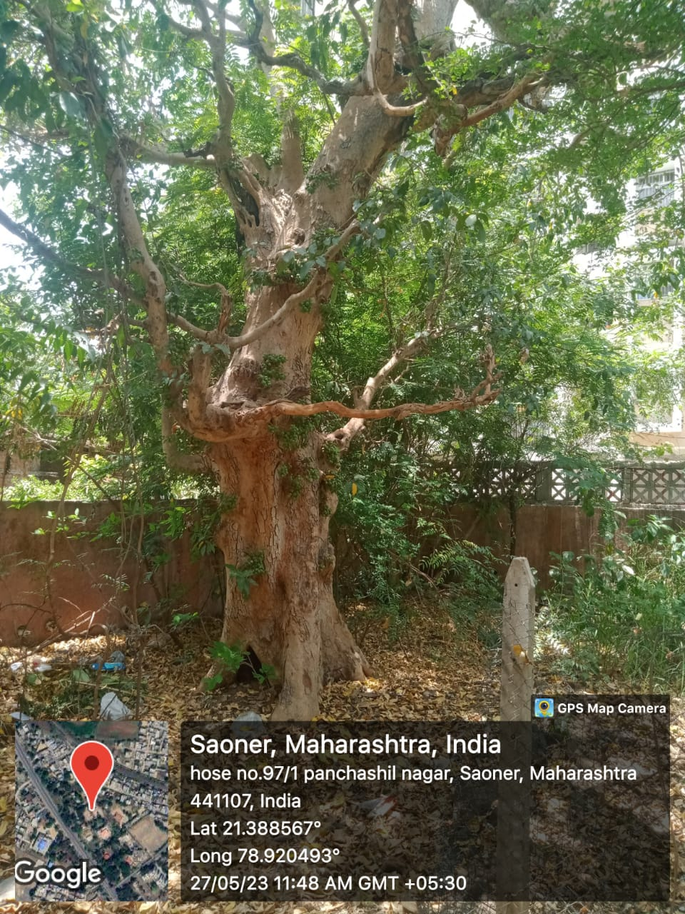

## Executive Summary

Tree census of Nagar Parishad was carried out in year 2022-2023. Geo-coordinates of each tree were recorded. The extensive field work was carried out and **10,994** trees are documented during the survey. For trees the attributes such as Common Name, scientific Name, local, Name, Age(Y), Height(M), Diameter (CM), Physical Status, Address, Ward No., Disease, Heritage, Ownership, Geolocation and Remarks were recorded in field. Summary of the result is given below:

|  |  |  |
| --- | --- | --- |
| SN | Component | Result and Description |
| 1. | Species | Total 187 tree species |
| 2. | Total trees recorded | Total 10,994 trees were counted in all ward. |
| 3. | Dominant tree species | Dominant Tree species is Tree with 1088 individuals’ species. |
| 4. | Healthy Tree population | 98.5 % of tree population is healthy with 10,832 individuals. |
| 5. | Ward with highest and lowest tree count | Ward MIDC has highest count with 2198 individuals. |

# Materials and Methods:

Census involves the collection of data of each and every tree present in the jurisdiction. In order to collect the primary data from the field, ‘PTIM VRUKSHA’, a mobile based geo-enabled survey application was developed. The ward boundaries from the City Nagar Parishad, were procured and calibrated in the survey application. Simultaneously, the data collected using mobile application was synchronized with the web-based application. This helped in the transfer of collected data on the field directly from the mobile application to the main server.

### Protocol of tree census



**3. Data**

**verification and addition of attributes.**

**4. Data**

**analysis**

**5. Report**

**preparation and submission.**

**1.**

**Planning.**

**2. Data**

**collection.**

Figure 4: Diagrammatic representation of the steps involve in the Tree Census.

### Mobile application

The application was installed in the GPS-enabled mobile devices (Make: - Moto, Model: Moto G Turbo Edition) were provided to the field officers. The wards were allocated to respective teams and the survey was carried out. ‘PTIM VRUKSHA’ is a mobile application used for the survey with a survey form installed for the conducting survey. Apart from tree identification, other attributes collected were the girth of tree species in meters at the level of 1.3 m above ground with a tailoring tape, further to it, approximate height, approximate age, approximate canopy diameter, health conditions, owner and any other specific observation. Data collected each day by the respective tree officers was uploaded to the main server on the same day. Every counted and recorded tree was marked with an oil pastel to avoid recounting or other counting errors.

# Results and Conclusions:

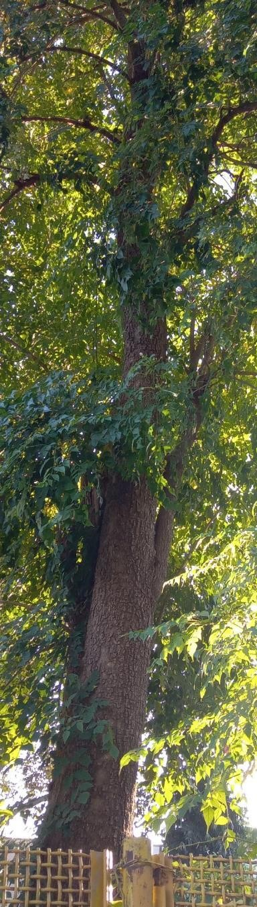

During the survey, 10,996 trees belonging to 187 species are geo-tagged in the survey. The results are categorized in various parameters *viz*., individual tree count, ward-wise tree count, ownership wise, height-wise, age-wise, canopy diameter-wise and condition wise.

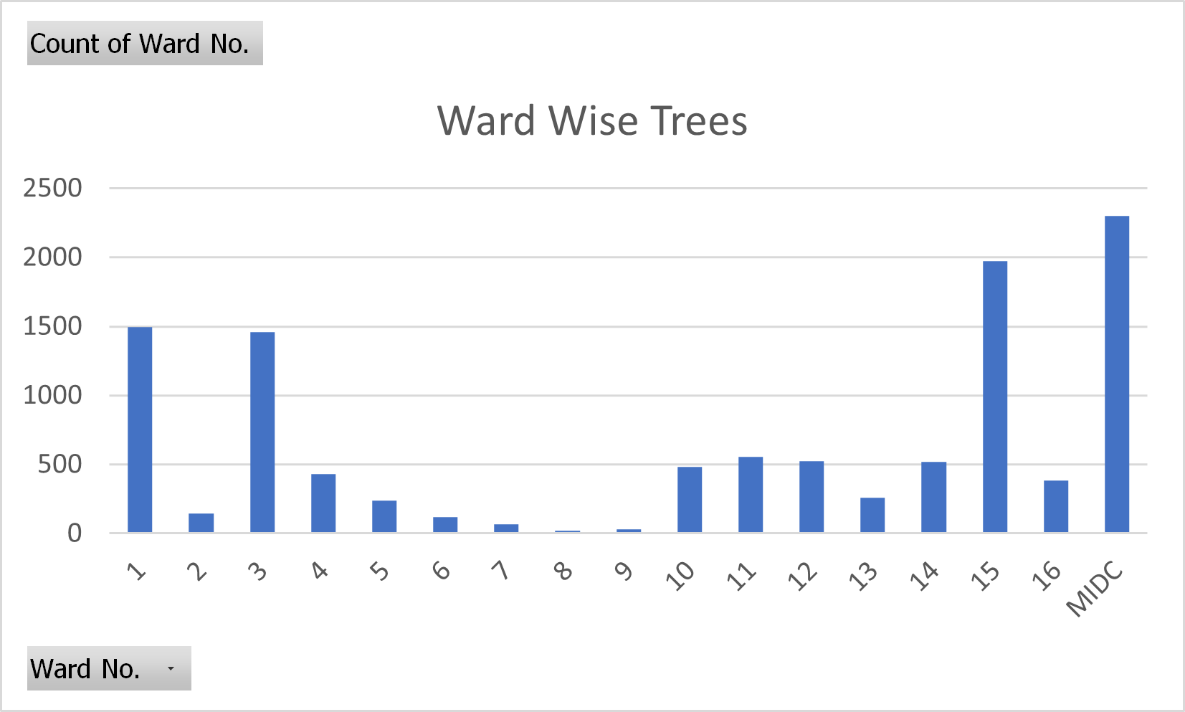

Figure: Ward with Tree count

### Ward wise trees:

|  |  |
| --- | --- |
| **Row Labels** | **Count of Ward No.** |
| 1 | 1497 |
| 2 | 145 |
| 3 | 1461 |
| 4 | 428 |
| 5 | 236 |
| 6 | 119 |
| 7 | 67 |
| 8 | 19 |
| 9 | 28 |
| 10 | 480 |
| 11 | 556 |
| 12 | 526 |
| 13 | 257 |
| 14 | 520 |
| 15 | 1971 |
| 16 | 383 |
| MIDC | 2301 |
| **Grand Total** | **10994** |

The total number of trees in the city is 10,994, which is a significant number and highlights the importance of trees in urban environments.

The percentage of trees varies widely across different wards, with the MIDC area having the highest percentage of trees at 20.93%.

Ward 1, with 13.60% of the city's trees, and Ward 15, with 17.92%, are also important areas for trees and should be protected and preserved.

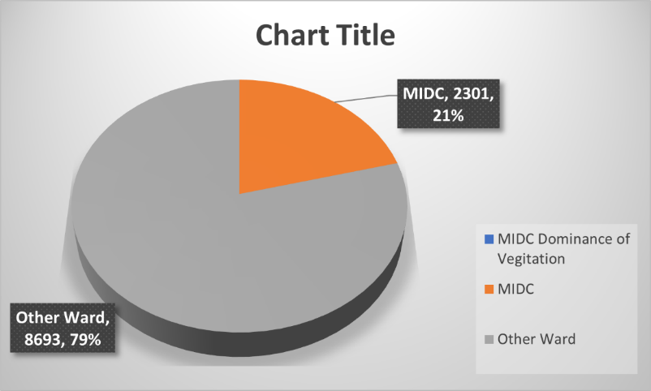

AGE WISE DISTRIBUTION OF

TREES IN THE CITY:

### Age of Trees:

### The classification of ages of trees is an important tool for monitoring, managing, and protecting trees and their ecosystems. It provides valuable information for decision-making and helps ensure that we can continue to enjoy the many benefits that trees provide.

|  |  |
| --- | --- |
| **Age Batch in Year** | **No. Of Trees** |
| 0 to 10 | 6450 |
| 11 to 49 | 4304 |
| 50 to 100 | 236 |
| Above 100 | 4 |
| **Grand Total** | **10994** |

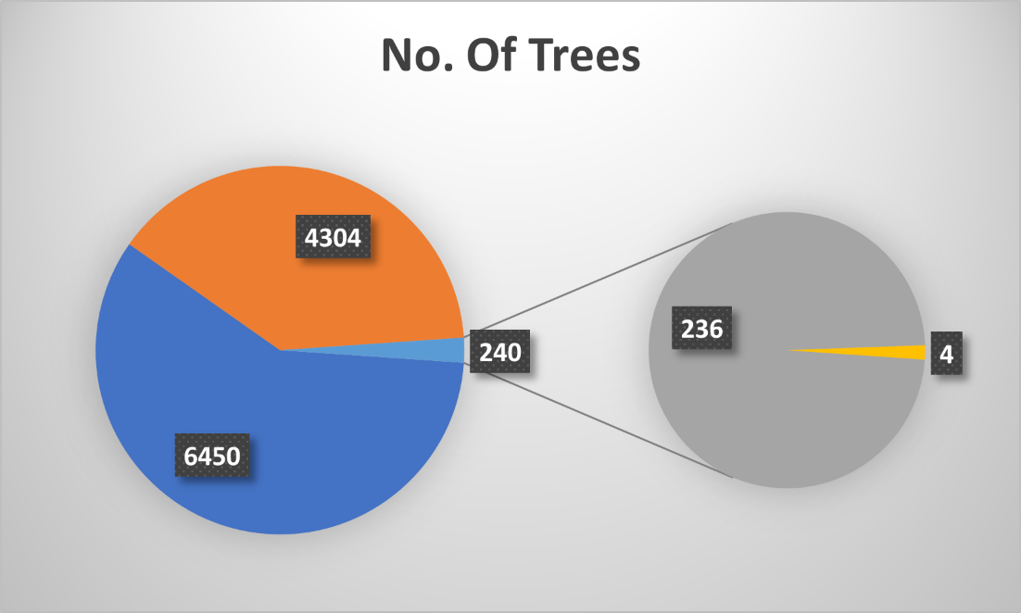

**Dig. Trees Proportion in AGE Categories**

**HERITAGE TREES IN THE CITY:**

## Heritage Trees:

Every tree has its role to perform in the ecosystem, further; it would differ in the ecosystem service the individual is providing to the community they exist within. With their long life span, trees provide a long lasting oxygen supply and other services too. Trees within the study area are well established, exhibiting an established urban habitat for the urban biodiversity. It is not advisable to disturbed an existing trees or the established garden sprawl within the landscape.

* 1. ***Selection Criteria***

World Heritage Convention & UNESCO, on the universal scale, has laid about 10 operational guidelines for the implementation to conserve the special architectural creations and the natural landscape. 6 out of 10 criterias are for cultural where as other 4 are dedicated to the natural landscape. Using the same guidelines, important tree species/ or urban green landscapes could be conserved on the region/ city level.

1. Important native tree species
2. Tree with the age criteria 50 years and above.
3. Identify the trees, having cultural value (worshiped during the various pooja), should be identified, mapped and conserved within the landscape.
4. Tree species falling in the RET (Rare, endangered and Threatened) status.
5. Tree species having an ecological importance such as confined to the special habitat and difficult to grow, native to eco-region or the country.
6. A large tree whose value is considerably irreplaceable.
7. Specimen associated with a historic person or event or happened to be a landmark for years.
8. Important forest tree species present within the existing landscape.

#### For Heritage trees, data collected is analysed in the following steps:

|  |  |
| --- | --- |
| **STEPS CRITERIAS** | |
| Step 1 | Trees with age 50 years and above is extracted from the data |
| Step 2 | Segregation of Native and Exotic trees individuals |
| Step 3 | Consideration of Rare Endangered and Threated category trees irrespective of their age and origin. |

**Number of Heritage Trees in the City are 273**

|  |  |
| --- | --- |
| TOTAL TREE | 10994 |
| HERITAGE TREE | 273 |

**Fig: Pie chart shows the presence of Heritage trees in the city.**

**Conclusion:**

In conclusion, the tree census provides valuable information on the distribution of trees in the city. The total number of trees in the city is 10,994, with significant variation in the percentage of trees across different wards. The MIDC area has the highest percentage of trees at 20.93%, followed by Ward 15 at 17.92% and Ward 1 at 13.60%. The presence of trees in urban areas has numerous benefits, including improved air quality and reduced urban heat island effect.

The tree census in City identified 187 species of trees, highlighting the biodiversity of the urban forest. This diversity of tree species is important for providing a range of ecological benefits and enhancing the aesthetic value of the city.

The data highlights the need for continued planting and maintenance of trees in urban areas, particularly in areas with lower percentages of trees. It also underscores the importance of preserving existing trees and protecting areas of the city that are at risk of losing trees. By prioritizing planting and conservation efforts, the city can promote a more sustainable and livable environment for its residents.

Overall, the tree census provides a valuable tool for understanding the distribution of trees in the city and identifying areas for action. With continued monitoring and management, the city can ensure that its urban forest continues to provide important benefits for years to come.

**References:**

* + 1. <https://whc.unesco.org/en/criteria/>
    2. [https://timesofindia.indiatimes.com/city/mumbai/maharashtra-to-give-heritage-tag-to- trees](https://timesofindia.indiatimes.com/city/mumbai/maharashtra-to-give-heritage-tag-to-trees)

that-are-over-50-yrs-old/articleshow/83416166.cms

* + 1. Down to earth article: Protecting heritage trees through a special law

THANK

YOU!